Indian Institute of Information Technology, Vadodara

College HR Management and Payroll System

Instruction Manual

CS301 Software Engineering Project – Autumn 2015

team #02 - ninEngineers

team #02 – ninEngineers:
Sr. No | Roll No. | Name
01. | 201351005 | Abhijit Singh Panwar
02. | 201351006 | Yash Choubey
03. | 201351017 | Rahul Nalawade
04. | 201351021 | Manu Sharma
05. | 201351023 | Murtuza Bohra
06. | 201351024 | Shalinee Singh
07. | 201351030 | Ajay Shewale
08. | 201352006 | Nitin Kumar Singh
09. | 201352013 | Sameer Bhati

Author/ Reviewer:
Author/ Reviewer | New Version | Date
Ajay Shewale | v1.0 | 24th September 2015
Rahul Nalawade | v1.1 | 17th October 2015
Manu Sharma | v1.2 | 26th October 2015
Shalinee Singh | v1.3 | 16th November 2015

Introduction

Payroll system is the heart of any Human Resource system of an organisation. And there are lots of HR and Payroll management systems that serve many organisations under different circumstances. But, most of them are static and require modifications according to the organisational needs.
Our Institute is in its developing phase. And the existing HR and Payroll System is managed manually by the administration. Besides, current course on Software Engineering deliberately expects us to do a project that will help our institute somehow.
We have develop a software solution to address the efforts and time-consuming manual operations of existing Payroll management by incorporating the software engineering practices.

Setting Up a Local Web Server

Our website execute on a web server running PHP. So before you start using website you need following program installed on your computer.
- The Apache web server
- The PHP engine
- The MySQL database server
- phpMyAdmin



You can either install them individually or choose a pre-configured package for you operating system like Linux and Windows. Popular pre-configured package are LAMP and XAMPP.
LAMP is for Ubuntu and XAMPP is for windows operating system. Below are installation process for both.

How to install Linux, Apache, MySQL, PHP (LAMP) on Ubuntu


LAMP
LAMP stack is a group of open source software used to get web servers up and running. The acronym stands for Linux, Apache, MySQL, and PHP. Since the virtual private server is already running Ubuntu, the linux part is taken care of. Here is how to install the rest.


Step 1 : Install Apache
Apache is a free open source software which runs over 50% of the world’s web servers.
To install apache, open terminal and type in these commands:
sudo apt-get update
sudo apt-get install apache2
That’s it. To check if Apache is installed, direct your browser to your server’s IP address (eg. http://12.34.56.789). The page should display the words “It works!" like this.

Step 2 : Install MySQL

MySQL is a powerful database management system used for organizing and retrieving data
To install MySQL, open terminal and type in these commands:
sudo apt-get install mysql-server libapache2-mod-auth-mysql php5-mysql
During the installation, MySQL will ask you to set a root password. If you miss the chance to set the password while the program is installing, it is very easy to set the password later from within the MySQL shell.
Once you have installed MySQL, we should activate it with this command:
sudo mysql_install_db


Step 3 : Install PHP
PHP is an open source web scripting language that is widely use to build dynamic webpages.
To install PHP, open terminal and type in this command.
sudo apt-get install php5 libapache2-mod-php5 php5-mcrypt

After you answer yes to the prompt twice, PHP will install itself.

Step 4 : Restart Server
Your server should restart Apache automatically after the installation of both MySQL and PHP. If it doesn't, execute this command.
sudo /etc/init.d/apache2 restart

Step 5 : Check Apache
Open a web browser and navigate to http://localhost/. You should see a message saying It works!

Step 6 : Check PHP
You can check your PHP by executing any PHP file from within /var/www/. Alternatively you can execute the following command, which will make PHP run the code without the need for creating a file
php -r 'echo "\n\nYour PHP installation is working fine.\n\n\n";'

YEAH, YOU HAVE INSTALL UBUNTU LAMP SERVER
SUCCESSFULLY !!

For further queries visit :
https://www.digitalocean.com/community/tutorials/how-to-install-linux-apache-mysql-php-lamp-stack-on-ubuntu
How to install XAMPP on Windows

XAMPP
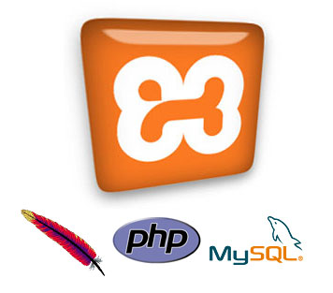
XAMPP is an Apache server distribution which has MySQL, PHP, PERL, and some other softwares like phpMyAdmin. A denotes Apache server, M stands for MySQL, P stands for PHP, and the last P is for PERL.

How to install?
Here is a link where you can download WampServer
https://www.apachefriends.org/download.html
- First you need to download the XAMPP installer for Windows from above link
- This page will show latest versions of XAMPP for Windows and also for other operating systems like linux, mac etc.
- Now click on “Download” in the page, and then it will automatically download XAMPP installer.

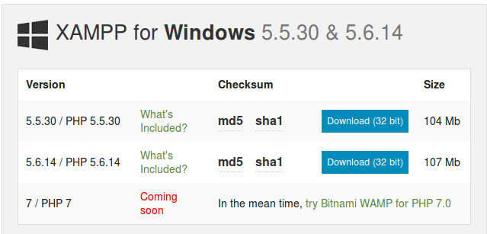

Installing XAMPP
Double click the downloaded setup.exe file to install XAMPP server as a local sever on your system. You’ll see the following window.

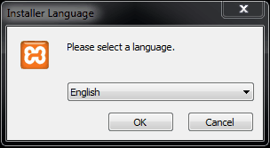

Select language

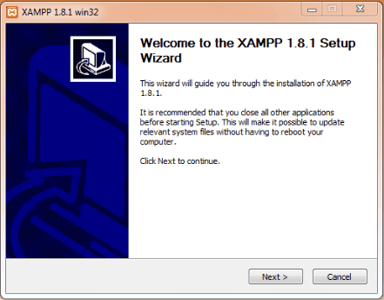

Click “next” to start installation process

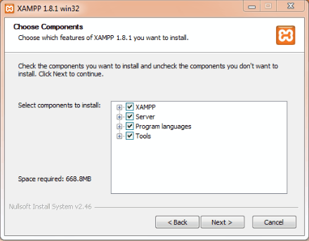

Select all components to install and click “next”

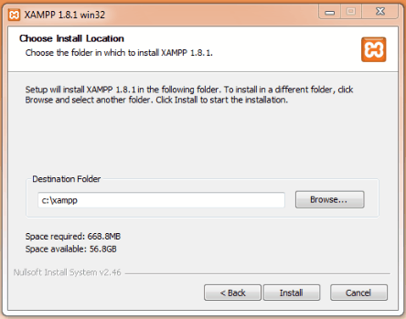

Choose install Location and click “install”

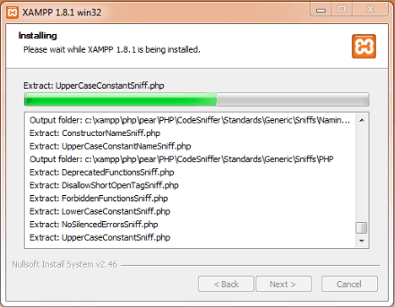

After Installing screen will be seen

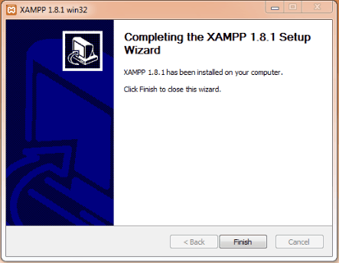

Click on “finish” to finish installation process

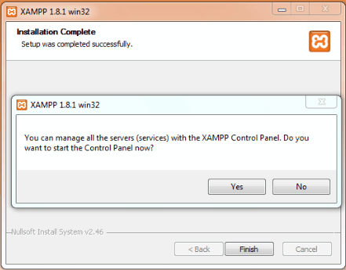

Dialog box will ask to open XAMPP Control Panel. Click on “Yes” it will open XAMPP control panel.

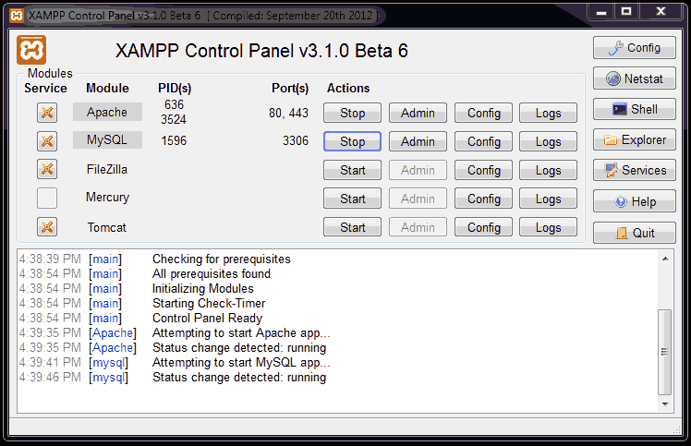
Click on start button next to Apache and MySQL, wait for both to start. Both Apache and MySQL are running now.
Now open any browser and type http//:localhost in the address bar and hit Enter! The browser will direct you to page shown below.


Click on language you have to select and you are done.

CONGRATULATIONS, YOU HAVE SUCCESSFULLY INSTALL XAMPP ON WINDOWS !!

Creating MySQL database

A database created to hold all the website data and user information. We will set this database up using phpmyadmin.
To access phpMyAdmin you will need to know the IP address or domain name of your server.
Open your browser and enter the the IP address or domain name of your server followed by /phpmyadmin

Login Page

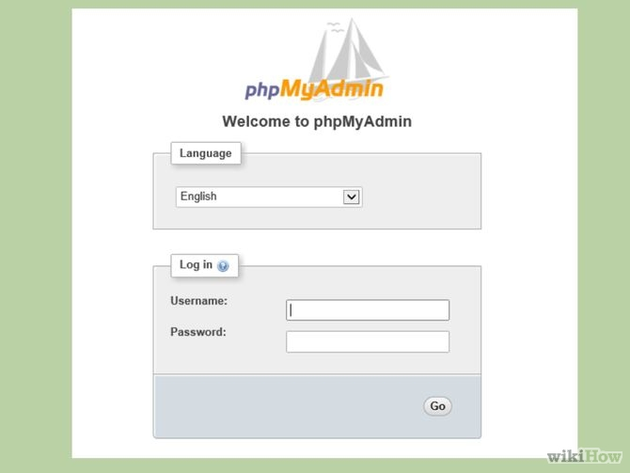


Login to phpMyAdmin : Enter root as a username and enter your MySql password in password field.
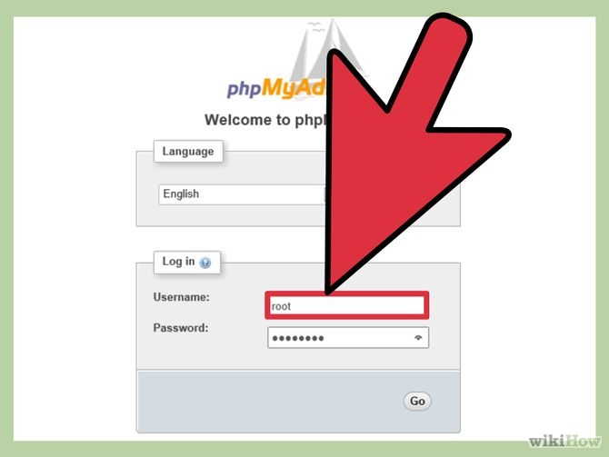

Create an empty database from the database tab

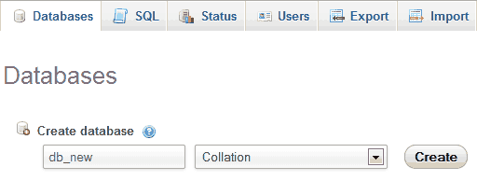
Write a database name in the “Create database” textfield, and click on Create
button. A database will be created.

Import database
- Click the Import tab.
- Click the Browse button.
- Locate the file to be imported.
- Click Open or OK, depending on your browser.
- Select the proper collation from the drop-down.
- Select the format of the import file.
- Click Go.

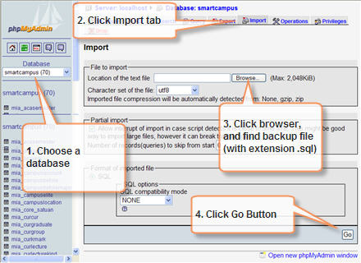

Running scripts
Before running PHP files, they should be placed inside the web folder of a web server and then make a request to desired PHP file by typing its URL in the web browser If you installed a web server in your computer, usually the root of its web folder can be accessed by typing http://localhost in the web browser. So, if you placed a file called hello.php inside its web folder, you can run that file by calling http://localhost/hello.php.

Windows users: XAMPP

Under XAMPP root directory there is a folder called htdocs. That’s where you should put your web site related stuff. For each web site you create, it’s better to create a folder inside htdocs folder and then put content inside that to avoid conflicts.
For example, you can create a folder called Payroll inside htdocs folder and put employee.php inside that. Then you can access it via URL
http://localhoost/payroll/employee.php
It will look for an index file which is inside the folder. So if you have index file in Payroll folder you would see its output once you typed http://localhost/Payroll/.

Linux users: LAMP

To run scripts they must be in the folder /var/www/ If you have a script called Admin.php you will have to browse to http://localhost/Admin to view it.

That's it.....

Reference

- https://www.digitalocean.com/community/tutorials/how-to-install-linux-apache-mysql-php-lamp-stack-on-ubuntu
- http://howtoubuntu.org/how-to-install-lamp-on-ubuntu
- https://www.apachefriends.org/download.html
- https://blog.udemy.com/xampp-tutorial/
- https://www.google.co.in/search?q=XAMPP+for+windows&client=ubuntu&hs=Okg&channel=fs&source=lnms&tbm=isch&sa=X&ved=0CAgQ_AUoAmoVChMI8fja3YeVyQIVQnCOCh0NpQ5M&biw=1307&bih=673
- http://www.wikihow.com/Create-a-Database-in-phpMyAdmin
- http://www.tutorialspoint.com/articles/run-a-php-program-in-xampp-server

